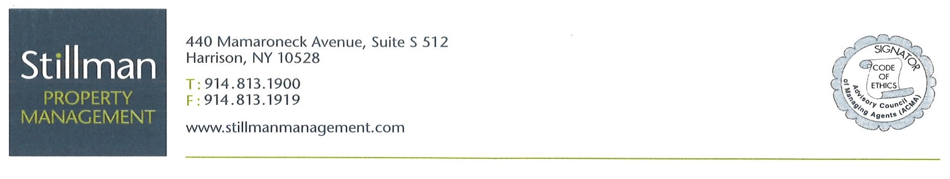

**M E M O**

To: All Residents of High Meadow Cooperative #1, Inc.

From: Stillman Management – Jenna Guiliano, Property Manager

Date: July 21, 2021

Subj: Landscaping Concerns

Management and the Board are aware of recent complaints that came in from residents which include but are not limited to additional chemical treatments being done without notification, weeding, and pruning that have not been addressed throughout the property.

We have voiced these concerns to the manager at BrightView landscaping who has been working closely with management and the facility office to remedy these complaints. We even have begun exploring organic treatments to possibly use going forward.

To catch up with the maintenance needed, Brightview landscaping will be onsite starting tomorrow until Saturday, July 24th with additional crew members for regular maintenance. They will also be weeding and pruning all the hedges throughout the property and spray the hedges with a growth inhibitor which will slow down the growth in between each pruning. This spray does not require the pesticide yellow warning signs to be placed and is odorless.

There is noise associated with their pruning such as weed trimmers. BrightView has promised to not make noise before 9:00 am.

We are hopeful that Brightview will improve its obligations to ensure that it gives the service our valued residents deserve and are used to.